ASG Airlines: End-to-End Data Engineering Case Study

- Problem Statement:
ASG Airlines operates flights across multiple cities, through its booking platforms, scheduling systems and airport logs. Inconsistencies noticed in the collected data, such as corrupted flight identifiers, inconsistent time format (in terms of duration) leading to unhandled overnight flight scenarios and missing values, created challenges in generating accurate operational insights. This project builds an end-to-end pipeline that ingests, cleans, standardizes and transforms raw flight data into a reliable dataset for reporting and BI.

2. Architecture / Data Flow:
Source
(4 sheets: flights, bookings, payments, passengers)
Power BI Desktop
(modelling, KPIs and dashboard)
Cleaned Data Exported as CSVs
Ingestion & Cleaning
(pandas, local environment)
3. Assumptions Made:
Overnight flights: There were records where the arrival_time was earlier than the departure_time, assumption made was that it crossed midnight and so 1 day was added to it before computing duration. Only 1 of 1020 flights needed this correction.

flight_id duplicates: There were 16 duplicates, of which 15 were actual duplicates (whole row duplicated), and these 15 were dropped. The remaining one, with ID 6F250 mapped to 2 different flights, and hence one of these was reassigned as 6F250_B to differentiate the records.

airline nulls / “UNKNOWN” values: There were 41 nulls and 30 “UNKNOWN” values, which were handled taking into consideration the prefix of the flight IDs, since the first 2 characters in it are unique to each airline (6F – Indigo, AI – Air India, SJ – SpiceJet, UK – Vistara)

passenger_id duplicates: 39 duplicate records, of which, after scanning the records, it was noticed that the same ID belonging to the same passenger had different details and there was no reliable way to determine which PII value was correct. A flag column was created, mapping those duplicates to “Duplicate”, and the rest as “Correct”.

Anomaly definition: Since there was no scheduled vs actual time data to calculate flight delays, flights in the top/bottom 5% of the duration were flagged as anomalies (94 of 1005 flights).

status in bookings had null values as well as “INVALID” values in payments under amounts were identified but were dismissed for further cleaning as the main problem focused on flights analysis.

4. Data Cleaning & Transformation Logic:

flights sheet (1020 to 1005 rows):
- Dropped the unreliable pre-calculated duration column, which was simply stored as an Excel formula and recalculated it using arrival_time – departure_time, adding a 1-day overnight correction first.
- Dropped 15 actual duplicates.
- Resolved 1 flight_id collision (6F250 to 6F250_B).
- Recovered airline nulls / “UNKNOWN” values using flight ID prefix mapping.
- Added an is_anomaly flag (top/bottom 5%).

payments sheet (1000 rows): not cleaned.

bookings sheet (1000 rows):
- passport_number, emergency_contact_name, emergency_contact_phone were hashed using SHA-256.

passengers sheet (1039 rows):
- Flagged 39 passenger_id duplicates, flagged conflicting PII details as “Duplicate”.
- aadhaar_id was hashed using SHA-256.
- email and phone were partially masked.

5. About the PII Masking & Privacy Control:

Sensitive passenger identifiers such as Aadhaar ID, passport number and emergency contact details were hashed using SHA-256. Contact details such as email and phone were partially masked, to allow for some level of readability while also protecting the full value. DOB was generalized to year of birth alone, which allows for age-related analysis, if required. In a usual production environment, having access to any unmasked PII should be restricted via RBAC, where only authorized personnel should be able to view raw values.

6. Data Model:

After cleaning and transformation, the data was exported as 3 CSVs (flights, bookings, passengers), rather than a single flat file.

Final schema for all 4:

flights – 1005 rows, 7 columns:
- flight_id – string
- airline – string
- source – string
- destination – string
- departure_time – datetime
- arrival_time – datetime
- duration – timedelta
- is_anomaly – Boolean
- duration_minutes – float

payments – 1000 rows, 4 columns:
- payment_id – string
- booking_id – string
- amount – float
- payment_method – string

bookings – 1000 rows, 9 columns:
- booking_id – string
- passenger_id – string
- flight_id – string
- booking_date – datetime
- status – string
- passport_number – string
- seat_number – string
- emergency_contact_name – string
- emergency_contact_phone – string

passengers – 1039 rows, 10 columns
- passenger_id – string
- first_name – string
- last_name – string
- age – int
- gender – string
- email – string
- phone – string
- aadhaar_id – string
- date_of_birth – int
- id_flag – string
7. Dashboard Walkthrough & Analysis:

The report was created spanning Duration Analysis, Route Performance, Airline Trends and Delay/Anomaly Insights.

Duration Analysis:
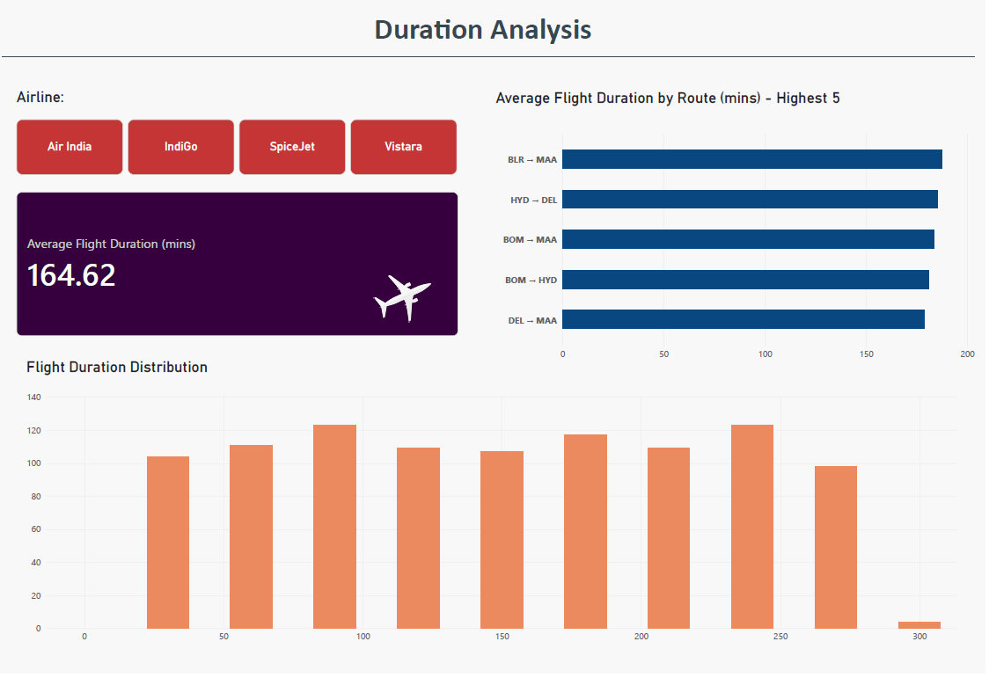
- The average flight duration is 165 minutes (2 hours, 45 minutes)
- Top 5 longest routes include Bengaluru to Chennai, Hyderabad to Delhi, Mumbai to Chennai, Mumbai to Hyderabad and Delhi to Chennai.
- Flight durations are evenly distributed across the 300-minute range, where most of the 30-minute buckets hold around 100 – 130 flights and very few cross 270 minutes.
- An airline filter was added for users to view metrics for a single carrier at a time, if required.
Route Performance:
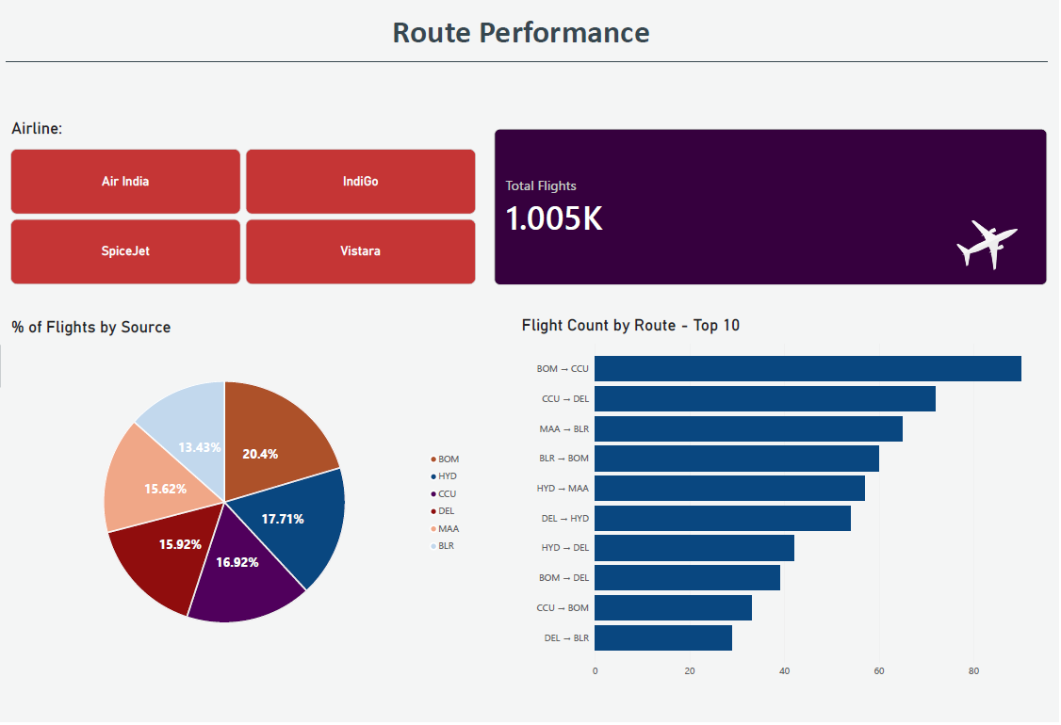

- 1005 total flights
- Mumbai (BOM) is the busiest source city (20.4% of flights), followed by Hyderabad (17.71%), Kolkata (16.92%), Delhi (15.92%), Chennai (15.62%) and Bengaluru (13.43%).
- Mumbai to Kolkata is the single busiest route by flight count, followed by Kolkata to Delhi and Chennai to Bengaluru.
- An airline filter again, let’s traffic be analyzed per carrier.

Airline Trends:
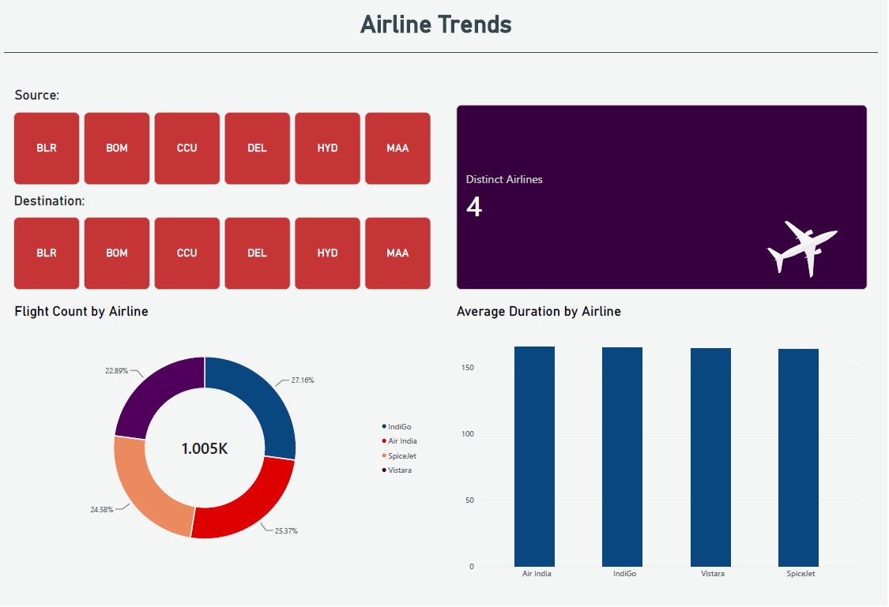

- 4 airlines operate across the network. These are IndiGo (27.16% of flights), Air India (25.37%), SpiceJet (24.58%) and Vistara (22.89%). This shows a fairly even split.
- The average flight duration across all the 4 airlines is almost similar, where no single airline shows a distinctly longer/shorter average.
- Source and destination filters allow for route-based analysis.

Delay/Anomaly Insights:
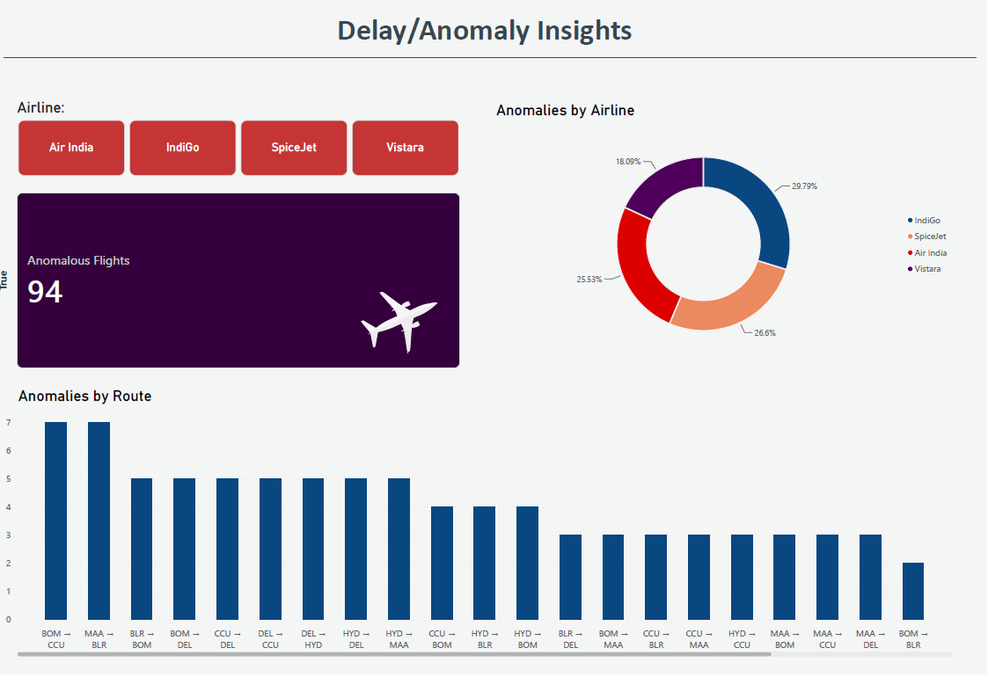

- 94 flights were flagged as statistical duration outliers, which lie in the top or bottom 5% of flight durations.
- IndiGo accounts for the most share of anomalies (29.79%), followed by SpiceJet (26.6%), Air India (25.53%) and Vistara (18.09%).
- Mumbai to Kolkata and Chennai to Bengaluru have the highest anomalies (7 each), of which they also happen to be among the busiest routes.
- An airline filter allows anomalies to be examined for one carrier at a time.

8. GitHub Repository:

https://github.com/aimee-joseph/NeoStats-ASGAirlines_AimeeJoseph

